Sub-THz Radar sensing of the Environment for future Autonomous Marine platforms – STREAM

Edgbaston Reservoir 05/11/2021 Data Repository Description

Project | STREAM
Document Title | Edgbaston Reservoir Data Repository Description
Document Reference | ERT-051121-Repos
Issue | 01
Date | 09/03/2022
Version History
Version | Date | Authored By | Comments
01 | 02/03/2022 | Dillon Kumar | First version
02 | 09/03/2022 | Dillon Kumar | Second version. Separation of trial dates, so datasets can clearly be accessed.

Contents
Abbreviations 4
1. Introduction 5
1.1 Overall trial objectives 5
1.2 Repository Overview 5
1.3 Measurement Site and Scene 5
2. Hardware Configuration for data collection 7
2.1 Full Equipment list for Edgbaston trials. 7
2.2 Calibration Targets 8
2.3 Video 9
2.4 Pola-Rad 79 9
2.5 Multi-Rad 150 9
3. Measurement Scenarios 10
3.1 Radar Calibration: ERST_051121_Corner 10
3.2 Radar surface scans: ERST_051121_Scan 10
3.3 Radar surface stares: ERST_051121_Stare 11
3.4 STREAM – Edgbaston Reservoir Data Repository Description 12
Appendix 14
Supporting Files 14
Reading data via MATLAB 14
Pola-Rad 79, Multi-Rad 150 14
INRAS Radarlog 15
Video 15
Timestamp 15

Abbreviations
CRF  CRI  FOG  GPS  IF  IMU  IRL  PCIe  RAM  UoB | Chirp Repetition Frequency  Chirp Repetition Interval  Fibre Optic Gyroscope  Global Positioning System  Intermediate Frequency  Inertial Measurement Unit  INRAS RadarLog  Peripheral Component Interconnect Express  Radar Absorbent Material  University of Birmingham

1. Introduction
This report describes the measurement scenarios and the structure of the data of the radar sensors used at the Edgbaston reservoir as part of an ongoing data-collection campaign as part of the STREAM project. Data was collected on 05/11/2021.
The dataset titled: ERST_051121 is a shakedown trial used to investigate the total operation of the sensing suite for later use in trials by the coastal waters.
The dataset titled: ERT_040222 is a trial that tests upgrades to the sensors, and the capability of obtaining DBS/SAR measurements.
- Chapter 2 provides a list of the sensors used in the trials, the configuration and the parameters. The data structure and how to access it is listed in the appendix.
- Chapter 3 gives the details of the measurement scenarios and the datasets that were recorded during the trial.
- Chapter 4 is a list of appendix data which is useful for accessing the data via MATLAB.

1.1 Overall trial objectives
The trial, denoted ERST_051121, was conducted as an overall radar system test of functionality and sensitivity of the radar sensing suite, for later use in maritime scenarios. Hence azimuth scans and single azimuth look angle stares of the reservoir environment were taken. Specifically measuring any local targets of opportunity and purposely placed reference targets.

1.2 Repository Overview
Table 1: Repository data overview
Trial code | Scenario | Description
ERST_051121_Corner | Radar Calibration | Scan with corner reflectors in scene to validate sensor operation.
ERST_051121_Scan | B-Scope measurement for anomaly detection. | Scan of reservoir surface, with targets of opportunity, passing through beam or pre-existing stationary targets on surface.
ERST_051121_Stare | A-Scope measurement for anomaly detection. | Staring measurement of reservoir surface, with targets of opportunity, passing through beam or pre-existing stationary targets on surface.
Due to the data limit of the online repository, the quoted datasets which are found in table 7 can be available on request. The provided datasets cover all types of radar configuration.
Note that the “blue_buoy_stare_2” dataset measurement from the 150 is available on request due to its large file size. The 79 GHz counterpart dataset is made available.

1.3 Measurement Site and Scene
The measurement site is located at the MSC entrance to the Edgbaston Reservoir, found at the latitude longitude co-ordinate: 52.48201398916361, -1.9358652034275814. Note that depending on the day, the reservoir level may be lower than that seen in figure 1, granting access for new orientations of the UoB test vehicle, hence new positions for the sensing suite. For calibration measurements, the tripod and corner reflector are placed along the path near the parked boats, offereing ranges up to 40 m.

Figure 1: Birds eye view of the test area at Edgbaston Reservoir.

2. Hardware Configuration for data collection
Data collection has been performed so far using a UoB test vehicle as seen below.
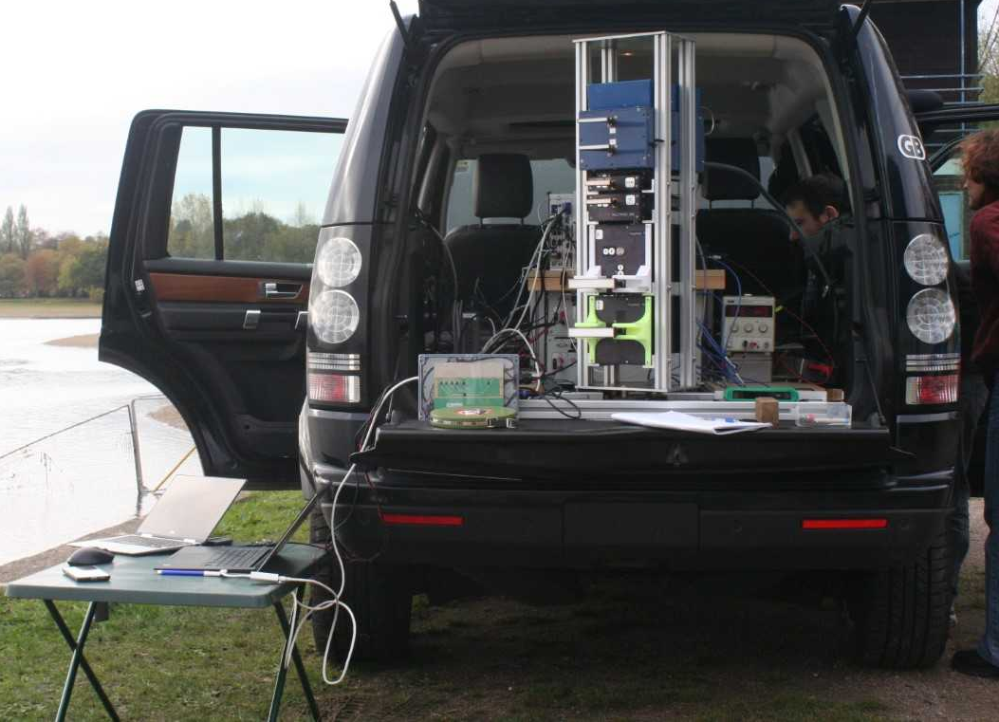
INRAS Radar Log
PolaRad 79
MultiRad 300
150 GHz Radar
Figure 2: Radar sensor suite in UoB test vehicle.
The equipment is installed into the vehicle using a metal rig that fits the dimensions of the test vehicles boot.

2.1 Full Equipment list for Edgbaston trials.
Table 2: Generalised equipment list for all trials.
Type | Description | Quantity
Radars | ELVA79 (PolaRad79) | 1
 | 150 GHz Radar (MultiRad150) | 1
 | ELVA300 (MultiRad300) | 1
 | INRAS Radarlog | 1
Antenna | Radar antenna for PolaRad79 Tx and Rx:  Fan beam lensed horns: 1.7° azimuth beam width, 7.2° elevation beam width.  10° standard horns. | 3x each antenna type
 | Radar antenna for MultiRad150 Tx and Rx:  Fan beam lensed horns: 1.8° azimuth beam width. | 2
 | Radar antenna for MultiRad300 Tx and Rx:  Fan beam lensed horns: 1.4° azimuth beam width.  GOLA pencil beam horns: 1° azimuth and elevation beam width. | 2x each antenna type
Optical devices | Stereolabs ZED stereo camera. | 1
 | Laser distance measure | 1
Additional Equipment/ Instruments | Small plastic table | 1
 | Land Rover Discovery | 1
 | Fanless PC | 1
 | Digitisers | 2
 | IMU | 1
 | Spectrum analyser | 1
 | Laptops (One for INRAS, One for ZED) | 2
 | Car Inverter | 1
 | Tool box (Screwdrivers, spanners, tape etc…) | 1
 | Spare parts box (RF cables, nuts, screws bolts etc…) | 1
 | Measuring tape (>30 m) | 1
 | Square plate corner reflector (7 cm) | 1
 | Square plate corner reflector (5 cm) | 1
 | Square plate corner reflector (2.5 cm) | 1
 | Height adjustable tripod | 1
 | Radar absorbent material (RAM) | 2
 | Portable Hard drives | 2
 | Walkie Talkies | 2
PPE/ Sustenance | Packed lunches/picnic | 1/participant
 | Steel toe cap boots | 1 pair/participant
 | Warm clothing (Hats scarfs gloves) | 1 set/participant
 | High visibility jackets | 1/ participant
Provided by midlands sailing club. | Toilets
 | Boats
 | Boat engine fuel
 | Ramp access
 | Mains electricity

2.2 Calibration Targets
Table 3: Calibration targets and the respective max RCS at radar centre frequencies.
Equipment | Parameters | Value | Units
Trihedral Corner Reflectors  (Square Plate) | Edge length | 7 | cm
 | Max RCS at 79 GHz | 17.98 | dBsm
 | Max RCS at 150 GHz | 23.55 | dBsm
 | Max RCS at 300 GHz | 29.57 | dBsm
 | Edge length | 5 | cm
 | Max RCS at 79 GHz | 12.14 | dBsm
 | Max RCS at 150 GHz | 17.71 | dBsm
 | Max RCS at 300 GHz | 23.73 | dBsm
 | Edge length | 2.5 | cm
 | Max RCS at 79 GHz | 0.09 | dBsm
 | Max RCS at 150 GHz | 5.66 | dBsm
 | Max RCS at 300 GHz | 11.68 | dBsm

2.3 Video
A ZED stereo video camera has been used to provide ground truth the radar measurements. Camera data is supplied as an H.264 encoded video file in an MP4 container and is timestamped to allow for co-registration with the radar data. However, there is some degree of error due to latency.
The computer connected to ZED captures video snapshots from the webcam, that are later synchronised with the radar data using time stamp information.

2.4 Pola-Rad 79
Pola-Rad 79 is a 79 GHz FMCW radar with 1 transmitter and a potential of up to 3 receivers that can be arbitrarily spaced at any distance. All operation of the Pola-Rad 79 is conducted on MATLAB, where FMCW parameters can be set. It also has its own FMCW chirp generator which can be used as a reference should problems arise with the 10 MHz distribution.
It uses a 10 MHz reference signal that is distributed amongst the other radars and is triggered in sync with the other radars and the ADC card to ensure there is no packet loss. The PCIe9834 digitiser ADC is used to collect the IF output data of the I and Q channels of the receiver.
Table 4a: Pola-Rad 79 parameters.
Radar Parameter | Value | Units | Comment
Centre Frequency, f | 78.5 | GHz
Transmit Power, P_{t} | 13 | dBm | Average across band
Noise Figure, NF | 10 (16) | dB | Best (Worst) value
PRF | 232 | Hz | Fastest
Chirp Duration | 1 | ms | Duration for fastest PRF
Bandwidth | 5 | GHz | Maximum value
Table 4b: Pola-Rad Antenna parameters
Antenna Type | Az. Beam Width  (Two Way)  [°] | El. Beam Width  (Two Way)  [°] | Antenna Gain  G_{t} = G_{r}  [dBi]
Elevation Fan Beam | 1.7 | 7.2 | 30

2.5 Multi-Rad 150
Multi-Rad 150 is a 150 GHz FMCW radar, with 1 transmitter and 1 receiver. It has the potential to reach a CRF of 10 KHz for doppler processing, usually set to this in staring measurements. The CRF for scanning is usually set to 200 Hz.
It uses a 10 MHz reference signal that is distributed amongst the other radars and is triggered in sync with the other radars and the ADC card to ensure there is no packet loss. The PCIe9834 digitiser ADC is used to collect the IF output data of the I and Q channels of the receiver.

Table 5a: Multi-Rad 150 Parameters.
Radar Parameter | Value | Units | Comment
Centre Frequency, f | 150 | GHz
Transmit Power, P_{t} | 11.8 dBm | dBm | Average across band
Noise Figure, NF |  | dB | Best (Worst) value
PRF | 10000 | Hz | Fastest
Chirp Duration | 0.05 | ms | Duration for fastest PRF
Bandwidth | 5 | GHz | Maximum value
Table 5b: Multi-Rad 150 antenna parameters.
Antenna Type | Az. Beam Width  (Two Way)  [°] | El. Beam Width  (Two Way)  [°] | Antenna Gain  G_{t} = G_{r}  [dBi]
Elevation Fan Beam | 1.2 | 8 | 27

3. Measurement Scenarios
In this section each trial, denoted by its trial code is explained, the relevant datasets can be found at the end of the section with a numerical description.

3.1 Radar Calibration: ERST_051121_Corner
These reference measurements are used to obtain data of a target of known RCS, as seen in table 3. These reference measurements serve as a test to see if the radars are achieving the expected sensitivity by analysing the SNR and power return of the corner.
To do this, a square-plate trihedral corner is placed on top of a tripod and is set around 30 m of the radar. The radar then takes a scan of the scene via the turntable and the corner is identified for analysis. Specific trial parameters are recorded in table 6.

3.2 Radar surface scans: ERST_051121_Scan
These scans are produced as the sensing suite looks out onto the water surface, with the turn table active and usually scanning an azimuth of 60 degrees.
As seen in figure 3, the radar data collected can be processed to achieve range profiles of the reservoir with targets of opportunity. This code, “analyse_all_051121” is described in the appendices.
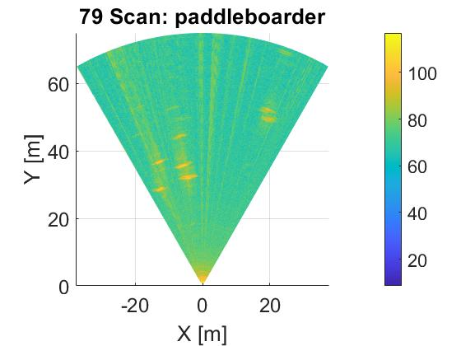
figure 3: Example of radar scan of reservoir surface.

3.3 Radar surface stares: ERST_051121_Stare
These measurements are produced by measuring one continuous look angle for a series of consecutive chirps, i.e. the turn table is disabled of the reservoir. Data is used to measure range profile against time.
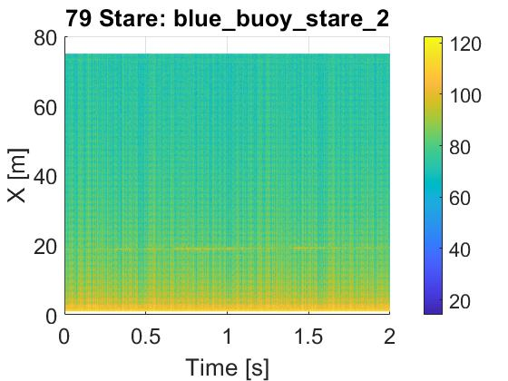
figure 4: example of stare data range profile vs time.

3.4 STREAM – Edgbaston Reservoir Data Repository Description
Table 6: Edgbaston Reservoir 051121 trial data repository description.
Trial Code | Measurement type + Description | Active Equipment | FMCW Parameters |  | Trial parameters | Radar data
 |  |  |  |  |  | 79 | 150
ERST_051121_Corner | Calibration.  3 sets of calibration scans with 2.5 cm corner on a tripod.  One dataset with 5 cm corner. | Pola-Rad 79  Multi-Rad 150  IRL  ZED  Turntable | 79 GHz  CRF: 200 Hz  Bandwidth: 5 GHz  Chirp duration: 1 ms  Start frequency: 76 GHz | 150 GHz  CRF: 200 Hz  Bandwidth: 5 GHz  Chirp duration: 1 ms  Start frequency: 145 GHz | Turntable  Frame rate: 1 Hz  FoV 60 degrees  Mode: Scanning  No. of Scans: 10  Scan time: 10 s  2.5 cm Corner  Position:  5.9 m: cal_1  13 m: cal_2  27 m: cal_3  5 cm Corner  27 m: cal_4 | cr2p5_first_cal_77300.DAT | cr2p5_first_cal_150.DAT
 |  |  |  |  |  | cr2p5_first_cal_2_77300.DAT | cr2p5_first_cal_2_150.DAT
 |  |  |  |  |  | cr2p5_first_cal_3_77300.DAT | cr2p5_first_cal_3_150.DAT
 |  |  |  |  |  | cr5_cal_4_77300.DAT | cr5_cal_4_150.DAT
ERST_051121_Scan | B-Scope | Pola-Rad 79  Multi-Rad 150  IRL  ZED  Turntable | 79 GHz  CRF: 200 Hz  Bandwidth: 5 GHz  Chirp duration: 1 ms  Start frequency: 76 GHz | 150 GHz  CRF: 200 Hz  Bandwidth: 5 GHz  Chirp duration: 1 ms  Start frequency: 145 GHz | Turntable  Frame rate: 1 Hz  FoV 60 degrees  Mode: Scanning  No. of Scans: 10  Scan time: 10 s | paddleboarder_77300.DAT | paddleboarder_150.DAT
 |  |  |  |  |  | paddleboarder_2_77300.DAT | paddleboarder_2_150.DAT
 |  |  |  |  |  | blue_buoy_1_77300.DAT | blue_buoy_1_150.DAT
ERST_051121_Stare | Staring measurements | Polar-Rad 79  Multi-Rad 150  IRL  ZED | 79 GHz  CRF: 200 Hz  Bandwidth: 5 GHz  Chirp duration: 1 ms  Start frequency: 76 GHz | 150 GHz  CRF: 10 KHz  Bandwidth: 5 GHz  Chirp duration: 90 µs  Start frequency: 145 GHz |  | yellow_buoy_77300.DAT | yellow_buot_150.DAT
 |  |  |  |  |  | yellow_buoy_2_77300.DAT | yellow_buoy_2_150.DAT
 |  |  |  |  |  | blue_buoy_stare_77300.DAT | blue_buoy_stare_150.DAT
 |  |  |  |  |  | blue_buoy_stare_2_77300.DAT | blue_buoy_stare_2_150.DAT
 |  |  |  |  |  | blue_buoy_stare_3_77300.DAT | blue_buoy_stare_3_150.DAT
 |  |  |  |  |  | blue_buoy_stare_4_77300.DAT | blue_buoy_stare_4_150.DAT
 |  |  |  |  |  | birds_1_77300.DAT | birds_1_150.DAT
 |  |  |  |  |  | birds_2_77300.DAT | birds_2_150.DAT

Appendix

Supporting Files
- Dataset_params: Each dataset is accompanied by a MATLAB Data file called Dataset_params, where the term Dataset is replaced by the specific dataset name.
- Dataset_zed: For datasets with the ZED active, replace the term Dataset with the specific dataset name. Zed optical data and depth maps are stored as an SVO, which can be converted to AVI: https://support.stereolabs.com/hc/en-us/articles/360009986754-How-do-I-convert-SVO-files-to-AVI-or-image-depth-sequences-
- Dataset_velodyne: For datasets with the velodyne lidar apparatus active, replace the term Dataset with the specific dataset name. – Data format for velodyne is in the velodyne VLP-16 manual: https://velodynelidar.com/wp-content/uploads/2019/12/63-9243-Rev-E-VLP-16-User-Manual.pdf
- Dataset_gps: For datasets with the GPS lidar apparatus active, replace the term Dataset with the specific dataset name.
- Dataset_fog: For datasets with the FOG lidar apparatus active, replace the term Dataset with the specific dataset name.

Reading data via MATLAB

Pola-Rad 79, Multi-Rad 150
The analyse_all_051121.m MATLAB code is used to load the data from the .DAT files into MATLAB. The file name is tagged at the end with the date (trial code), which corresponds to the dataset trial codes.
The first section named “Files” is used to load the dataset and its parameters into MATLAB. Before running this section, the ‘Analysispath’ string variable must be set as the directory to where the folder “+PCIe9834” exists. This MATLAB mex code is used to translate the .DAT files saved through the PCIe9834 digitser card into MATLAB. Changing the “Dataset” string variable to the dataset name as listed in the tables 6 will load that dataset and its parameter file.
The next control panel labelled radar measurement is a control panel that lets you change how the dataset is interpreted.
- RadarVideoMode:
- Set to 0 to only load the radar data that pertains to 1 frame/1 full turn of the turntable. Radar data will load as a matrix of ADC bin number x chirp number.
- Set to 1 to load the data for a selected number of frames. Radar data will loaded as a matrix of ADC bin number x chirp number x frame number named RawIF(Radarfeq).
- rdrScanNum:
- For RadarVideoMode = 0, sets the frame that will be loaded, integer value. (Integer).
- For RadarVideoMode = 1, sets the array of successive frames to be loaded. (Array of Integers).
- minRng: The minimum range that will be plotted after processing the raw IF data.
- maxRng: The maximum range that will be plotted after processing the raw IF data.
- intTime: If the data is staring (Recorded in params file), dictates how many seconds of data to load and analyse.
- Startchirp: If the data is staring (Recorded in params file), chooses which chirp to start the analysis from.
Once the control panel is amended, advance to the next section to load all the data and processing into the corresponding radar a-scope/b-scope. The section after that can be run to display the radar data:
- Staring: Radar a-scope plot, range (m) against time (s) with power in dBarb.
- Scanning: Single frame plot of x (m) against y (m) with power in dBarb.
- Video: Successive “scanning” frames updated every 0.5s, with title update (time s).

INRAS Radarlog
This sub-section gives the configuration of the Inras Radarlog, used to collect the data within the file. The parameters are stored as structure with the following fields. Most of the values are either calculated from the FMCW parameters described previous, or are set explicitly.
- fStart: Start frequency of the FMCW signal in Hz
- fStop: Stop frequency of the FMCW signal in Hz
- TrampUp: Ramp-up time of the FMCW signal in sec
- TrampDo: Ramp-down time of the FMCW signal in sec
- Tint: Frame interval time in secs
- Tp: Chirp interval time in sec
- N: Requested number of samples to be read per chirp
- TxSeq: TDMA ordering of Tx sequence in MIMO mode
Correct MIMO beamforming requires the application of calibration data in order to account for the fixed phase deviations which can be expected to occur due to the manufacturing variations. This calibration data is based on our measured data and is provided in the form of complex exponential which must be multiplied across the virtual phase array prior to beamforming (i.e. second matrix dimension).
Note that the raw data captured from radarlog is real and NOT complex.
The h5 file produced from the IRL can be read using the basic_data_read MATLAB code. To access the data, change the directory string to the directory containing the IRL data. Ensure that the directory that contains “RadarlogH5FileReader.m” is added to the path via the function “addpath”.

Video
Video.mp4: Video file containing the left camera image from stereo camera

Timestamp
RLG_Time: Text file containing timestamp when each radarlog frame is received by the laptop (not entirely accurate due to latency)
RBK_Time: Text file containing timestamps when each radarbook frame is received by the laptop (i.e. not entirely accurate due to latency)

